Introduction to ASP.NET Web Programming Using the Razor Syntax (C#)
By Microsoft ASP.NET Team|May 22, 2012
This article gives you an overview of programming with ASP.NET Web Pages using the Razor syntax. ASP.NET is Microsoft's technology for running dynamic web pages on web servers. This articles focuses on using the C# programming language.
What you'll learn:
- The top 8 programming tips for getting started with programming ASP.NET Web Pages using Razor syntax.
- Basic programming concepts you'll need.
- What ASP.NET server code and the Razor syntax is all about.
Note The information in this article applies to ASP.NET Web Pages 1.0 and Web Pages 2. Where there are differences between versions, the text describes the differences.

The Top 8 Programming Tips
This section lists a few tips that you absolutely need to know as you start writing ASP.NET server code using the Razor syntax.
Note The Razor syntax is based on the C# programming language, and that's the language that's used most often with ASP.NET Web Pages. However, the Razor syntax also supports the Visual Basic language, and everything you see you can also do in Visual Basic. For details, see the appendix Visual Basic Language and Syntax.
You can find more details about most of these programming techniques later in the article.

1. You add code to a page using the @ character
The @ character starts inline expressions, single statement blocks, and multi-statement blocks:
<!-- Single statement blocks -->
@{ var total = 7; }
@{ var myMessage = "Hello World"; }
<!-- Inline expressions -->
<p>The value of your account is: @total </p>
<p>The value of myMessage is: @myMessage</p>
<!-- Multi-statement block -->
@{
var greeting = "Welcome to our site!";
var weekDay = DateTime.Now.DayOfWeek;
var greetingMessage = greeting + " Today is: " + weekDay;
}
<p>The greeting is: @greetingMessage</p>
This is what these statements look like when the page runs in a browser:
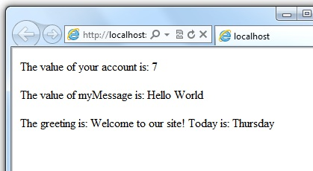

HTML Encoding
When you display content in a page using the @ character, as in the preceding examples, ASP.NET HTML-encodes the output. This replaces reserved HTML characters (such as < and > and &) with codes that enable the characters to be displayed as characters in a web page instead of being interpreted as HTML tags or entities. Without HTML encoding, the output from your server code might not display correctly, and could expose a page to security risks.
If your goal is to output HTML markup that renders tags as markup (for example <p></p> for a paragraph or <em></em> to emphasize text), see the section Combining Text, Markup, and Code in Code Blocks later in this article.
You can read more about HTML encoding in Working with Forms.

2. You enclose code blocks in braces
A code block includes one or more code statements and is enclosed in braces.
<!-- Single statement block. -->
@{ var theMonth = DateTime.Now.Month; }
<p>The numeric value of the current month: @theMonth</p>
<!-- Multi-statement block. -->
@{
var outsideTemp = 79;
var weatherMessage = "Hello, it is " + outsideTemp + " degrees.";
}
<p>Today's weather: @weatherMessage</p>
The result displayed in a browser:
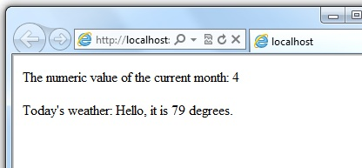

3. Inside a block, you end each code statement with a semicolon
Inside a code block, each complete code statement must end with a semicolon. Inline expressions don't end with a semicolon.
<!-- Single-statement block -->
@{ var theMonth = DateTime.Now.Month; }
<!-- Multi-statement block -->
@{
var outsideTemp = 79;
var weatherMessage = "Hello, it is " + outsideTemp + " degrees.";
}
<!-- Inline expression, so no semicolon -->
<p>Today's weather: @weatherMessage</p>

4. You use variables to store values
You can store values in a variable, including strings, numbers, and dates, etc. You create a new variable using the var keyword. You can insert variable values directly in a page using @.
<!-- Storing a string -->
@{ var welcomeMessage = "Welcome, new members!"; }
<p>@welcomeMessage</p>
<!-- Storing a date -->
@{ var year = DateTime.Now.Year; }
<!-- Displaying a variable -->
<p>Welcome to our new members who joined in @year!</p>
The result displayed in a browser:
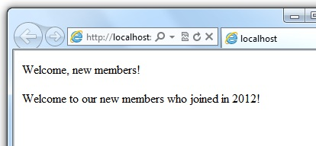

5. You enclose literal string values in double quotation marks
A string is a sequence of characters that are treated as text. To specify a string, you enclose it in double quotation marks:
@{ var myString = "This is a string literal"; }
If the string that you want to display contains a backslash character (\) or double quotation marks ( " ), use a verbatim string literal that's prefixed with the @ operator. (In C#, the \ character has special meaning unless you use a verbatim string literal.)
<!-- Embedding a backslash in a string -->
@{ var myFilePath = @"C:\MyFolder\"; }
<p>The path is: @myFilePath</p>
To embed double quotation marks, use a verbatim string literal and repeat the quotation marks:
<!-- Embedding double quotation marks in a string -->
@{ var myQuote = @"The person said: ""Hello, today is Monday."""; }
<p>@myQuote</p>
Here's the result of using both of these examples in a page:
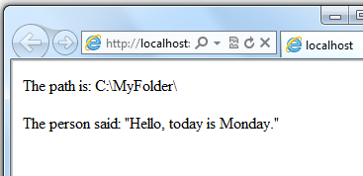
Note Notice that the @ character is used both to mark verbatim string literals in C# and to mark code in ASP.NET pages.

6. Code is case sensitive
In C#, keywords (like var, true, and if) and variable names are case sensitive. The following lines of code create two different variables, lastName and LastName.
@{
var lastName = "Smith";
var LastName = "Jones";
}
If you declare a variable as var lastName = "Smith"; and if you try to reference that variable in your page as @LastName, an error results because LastName won't be recognized.
Note In Visual Basic, keywords and variables are not case sensitive.

7. Much of your coding involves objects
An object represents a thing that you can program with — a page, a text box, a file, an image, a web request, an email message, a customer record (database row), etc. Objects have properties that describe their characteristics and that you can read or change — a text box object has a Text property (among others), a request object has a Url property, an email message has a From property, and a customer object has a FirstName property. Objects also have methods that are the "verbs" they can perform. Examples include a file object's Save method, an image object's Rotate method, and an email object's Send method.
You'll often work with the Request object, which gives you information like the values of text boxes (form fields) on the page, what type of browser made the request, the URL of the page, the user identity, etc. The following example shows how to access properties of the Request object and how to call the MapPath method of the Request object, which gives you the absolute path of the page on the server:
<table border="1">
<tr>
<td>Requested URL</td>
<td>Relative Path</td>
<td>Full Path</td>
<td>HTTP Request Type</td>
</tr>
<tr>
<td>@Request.Url</td>
<td>@Request.FilePath</td>
<td>@Request.MapPath(Request.FilePath)</td>
<td>@Request.RequestType</td>
</tr>
</table>
The result displayed in a browser:
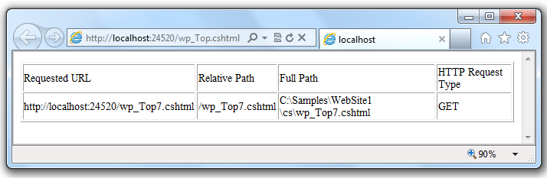

8. You can write code that makes decisions
A key feature of dynamic web pages is that you can determine what to do based on conditions. The most common way to do this is with the if statement (and optional else statement).
@{
var result = "";
if(IsPost)
{
result = "This page was posted using the Submit button.";
}
else
{
result = "This was the first request for this page.";
}
}
<!DOCTYPE html>
<html>
<head>
<title></title>
</head>
<body>
<form method="POST" action="" >
<input type="Submit" name="Submit" value="Submit"/>
<p>@result</p>
</form>
</body>
</html>
</body>
</html>
The statement if(IsPost) is a shorthand way of writing if(IsPost == true). Along with if statements, there are a variety of ways to test conditions, repeat blocks of code, and so on, which are described later in this article.
The result displayed in a browser (after clicking Submit):
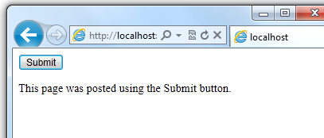

HTTP GET and POST Methods and the IsPost Property
The protocol used for web pages (HTTP) supports a very limited number of methods (verbs) that are used to make requests to the server. The two most common ones are GET, which is used to read a page, and POST, which is used to submit a page. In general, the first time a user requests a page, the page is requested using GET. If the user fills in a form and then clicks a submit button, the browser makes a POST request to the server.
In web programming, it's often useful to know whether a page is being requested as a GET or as a POST so that you know how to process the page. In ASP.NET Web Pages, you can use the IsPost property to see whether a request is a GET or a POST. If the request is a POST, the IsPost property will return true, and you can do things like read the values of text boxes on a form. Many examples you'll see show you how to process the page differently depending on the value of IsPost.

A Simple Code Example
This procedure shows you how to create a page that illustrates basic programming techniques. In the example, you create a page that lets users enter two numbers, then it adds them and displays the result.
- In your editor, create a new file and name it AddNumbers.cshtml.
- Copy the following code and markup into the page, replacing anything already in the page.
@{
var total = 0;
var totalMessage = "";
if(IsPost) {
// Retrieve the numbers that the user entered.
var num1 = Request["text1"];
var num2 = Request["text2"];
// Convert the entered strings into integers numbers and add.
total = num1.AsInt() + num2.AsInt();
totalMessage = "Total = " + total;
}
}
<!DOCTYPE html>
<html lang="en">
<head>
<title>Add Numbers</title>
<meta charset="utf-8" />
<style type="text/css">
body {background-color: beige; font-family: Verdana, Arial;
margin: 50px; }
form {padding: 10px; border-style: solid; width: 250px;}
</style>
</head>
<body>
<p>Enter two whole numbers and then click <strong>Add</strong>.</p>
<form action="" method="post">
<p><label for="text1">First Number:</label>
<input type="text" name="text1" />
</p>
<p><label for="text2">Second Number:</label>
<input type="text" name="text2" />
</p>
<p><input type="submit" value="Add" /></p>
</form>
<p>@totalMessage</p>
</body>
</html>
Here are some things for you to note:
  - The @ character starts the first block of code in the page, and it precedes the totalMessage variable that's embedded near the bottom of the page.
  - The block at the top of the page is enclosed in braces.
  - In the block at the top, all lines end with a semicolon.
  - The variables total, num1, num2, and totalMessage store several numbers and a string.
  - The literal string value assigned to the totalMessage variable is in double quotation marks.
  - Because the code is case-sensitive, when the totalMessage variable is used near the bottom of the page, its name must match the variable at the top exactly.
  - The expression num1.AsInt() + num2.AsInt() shows how to work with objects and methods. The AsInt method on each variable converts the string entered by a user to a number (an integer) so that you can perform arithmetic on it.
  - The <form> tag includes a method="post" attribute. This specifies that when the user clicks Add, the page will be sent to the server using the HTTP POST method. When the page is submitted, the if(IsPost) test evaluates to true and the conditional code runs, displaying the result of adding the numbers.
- Save the page and run it in a browser. (Make sure the page is selected in the Files workspace before you run it.) Enter two whole numbers and then click the Add button.
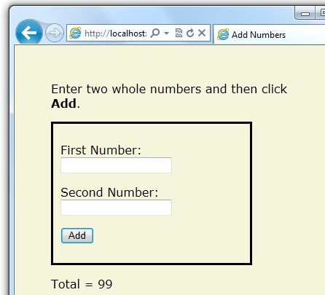

Basic Programming Concepts
This article provides you with an overview of ASP.NET web programming. It isn't an exhaustive examination, just a quick tour through the programming concepts you'll use most often. Even so, it covers almost everything you'll need to get started with ASP.NET Web Pages.
But first, a little technical background.

The Razor Syntax, Server Code, and ASP.NET
Razor syntax is a simple programming syntax for embedding server-based code in a web page. In a web page that uses the Razor syntax, there are two kinds of content: client content and server code. Client content is the stuff you're used to in web pages: HTML markup (elements), style information such as CSS, maybe some client script such as JavaScript, and plain text.
Razor syntax lets you add server code to this client content. If there's server code in the page, the server runs that code first, before it sends the page to the browser. By running on the server, the code can perform tasks that can be a lot more complex to do using client content alone, like accessing server-based databases. Most importantly, server code can dynamically create client content — it can generate HTML markup or other content on the fly and then send it to the browser along with any static HTML that the page might contain. From the browser's perspective, client content that's generated by your server code is no different than any other client content. As you've already seen, the server code that's required is quite simple.
ASP.NET web pages that include the Razor syntax have a special file extension (.cshtml or .vbhtml). The server recognizes these extensions, runs the code that's marked with Razor syntax, and then sends the page to the browser.

Where does ASP.NET fit in?
Razor syntax is based on a technology from Microsoft called ASP.NET, which in turn is based on the Microsoft .NET Framework. The.NET Framework is a big, comprehensive programming framework from Microsoft for developing virtually any type of computer application. ASP.NET is the part of the .NET Framework that's specifically designed for creating web applications. Developers have used ASP.NET to create many of the largest and highest-traffic websites in the world. (Any time you see the file-name extension .aspx as part of the URL in a site, you'll know that the site was written using ASP.NET.)
The Razor syntax gives you all the power of ASP.NET, but using a simplified syntax that's easier to learn if you're a beginner and that makes you more productive if you're an expert. Even though this syntax is simple to use, its family relationship to ASP.NET and the .NET Framework means that as your websites become more sophisticated, you have the power of the larger frameworks available to you.
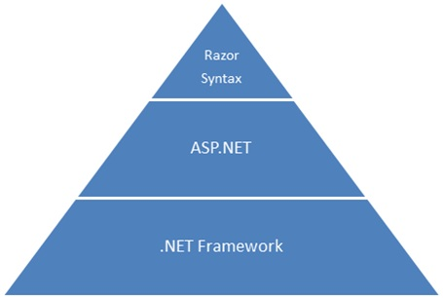

Classes and Instances
ASP.NET server code uses objects, which are in turn built on the idea of classes. The class is the definition or template for an object. For example, an application might contain a Customer class that defines the properties and methods that any customer object needs.
When the application needs to work with actual customer information, it creates an instance of (or instantiates) a customer object. Each individual customer is a separate instance of the Customer class. Every instance supports the same properties and methods, but the property values for each instance are typically different, because each customer object is unique. In one customer object, the LastName property might be "Smith"; in another customer object, the LastName property might be "Jones."
Similarly, any individual web page in your site is a Page object that's an instance of the Page class. A button on the page is a Button object that is an instance of the Button class, and so on. Each instance has its own characteristics, but they all are based on what's specified in the object's class definition.

Basic Syntax
Earlier you saw a basic example of how to create an ASP.NET Web Pages page, and how you can add server code to HTML markup. Here you'll learn the basics of writing ASP.NET server code using the Razor syntax — that is, the programming language rules.
If you're experienced with programming (especially if you've used C, C++, C#, Visual Basic, or JavaScript), much of what you read here will be familiar. You'll probably need to familiarize yourself only with how server code is added to markup in .cshtml files.

Combining Text, Markup, and Code in Code Blocks
In server code blocks, you often want to output text or markup (or both) to the page. If a server code block contains text that's not code and that instead should be rendered as is, ASP.NET needs to be able to distinguish that text from code. There are several ways to do this.
- Enclose the text in an HTML element like <p></p> or <em></em>:
@if(IsPost) {
// This line has all content between matched <p> tags.
<p>Hello, the time is @DateTime.Now and this page is a postback!</p>
} else {
// All content between matched tags, followed by server code.
<p>Hello <em>stranger</em>, today is: <br /> </p> @DateTime.Now
}
The HTML element can include text, additional HTML elements, and server-code expressions. When ASP.NET sees the opening HTML tag (for example, <p>), it renders everything including the element and its content as is to the browser, resolving server-code expressions as it goes.
- Use the @: operator or the <text> element. The @: outputs a single line of content containing plain text or unmatched HTML tags; the <text> element encloses multiple lines to output. These options are useful when you don't want to render an HTML element as part of the output.
@if(IsPost) {
// Plain text followed by an unmatched HTML tag and server code.
@: The time is: <br /> @DateTime.Now
<br/>
// Server code and then plain text, matched tags, and more text.
@DateTime.Now @:is the <em>current</em> time.
}
If you want to output multiple lines of text or unmatched HTML tags, you can precede each line with @:, or you can enclose the line in a <text> element. Like the @: operator, <text> tags are used by ASP.NET to identify text content and are never rendered in the page output.
@if(IsPost) {
// Repeat the previous example, but use <text> tags.
<text>
The time is: <br /> @DateTime.Now
<br/>
@DateTime.Now is the <em>current</em> time.
</text>
}
@{
var minTemp = 75;
<text>It is the month of @DateTime.Now.ToString("MMMM"), and
it's a <em>great</em> day! <br /><p>You can go swimming if it's at
least @minTemp degrees. </p></text>
}
The first example repeats the previous example but uses a single pair of <text> tags to enclose the text to render. In the second example, the <text> and </text> tags enclose three lines, all of which have some uncontained text and unmatched HTML tags (<br />), along with server code and matched HTML tags. Again, you could also precede each line individually with the @: operator; either way works.
Note When you output text as shown in this section — using an HTML element, the @: operator, or the <text> element — ASP.NET doesn't HTML-encode the output. (As noted earlier, ASP.NET does encode the output of server code expressions and server code blocks that are preceded by @, except in the special cases noted in this section.)

Whitespace
Extra spaces in a statement (and outside of a string literal) don't affect the statement:
@{ var lastName = "Smith"; }
A line break in a statement has no effect on the statement, and you can wrap statements for readability. The following statements are the same:
@{ var theName =
"Smith"; }
@{
var
personName
=
"Smith"
;
}
However, you can't wrap a line in the middle of a string literal. The following example doesn't work:
@{ var test = "This is a long
string"; } // Does not work!
To combine a long string that wraps to multiple lines like the above code, there are two options. You can use the concatenation operator (+), which you'll see later in this article. You can also use the @ character to create a verbatim string literal, as you saw earlier in this article. You can break verbatim string literals across lines:
@{ var longString = @"This is a
long
string";
}

Code (and Markup) Comments
Comments let you leave notes for yourself or others. They also allow you to disable (comment out) a section of code or markup that you don't want to run but want to keep in your page for the time being.
There's different commenting syntax for Razor code and for HTML markup. As with all Razor code, Razor comments are processed (and then removed) on the server before the page is sent to the browser. Therefore, the Razor commenting syntax lets you put comments into the code (or even into the markup) that you can see when you edit the file, but that users don't see, even in the page source.
For ASP.NET Razor comments, you start the comment with @* and end it with *@. The comment can be on one line or multiple lines:
@* A one-line code comment. *@
@*
This is a multiline code comment.
It can continue for any number of lines.
*@
Here is a comment within a code block:
@{
@* This is a comment. *@
var theVar = 17;
}
Here is the same block of code, with the line of code commented out so that it won't run:
@{
@* This is a comment. *@
@* var theVar = 17; *@
}
Inside a code block, as an alternative to using Razor comment syntax, you can use the commenting syntax of the programming language you're using, such as C#:
@{
// This is a comment.
var myVar = 17;
/* This is a multi-line comment
that uses C# commenting syntax. */
}
In C#, single-line comments are preceded by the // characters, and multi-line comments begin with /* and end with */. (As with Razor comments, C# comments are not rendered to the browser.)
For markup, as you probably know, you can create an HTML comment:
<!-- This is a comment. -->
HTML comments start with <!-- characters and end with -->. You can use HTML comments to surround not only text, but also any HTML markup that you may want to keep in the page but don't want to render. This HTML comment will hide the entire content of the tags and the text they contain:
<!-- <p>This is my paragraph.</p> -->
Unlike Razor comments, HTML comments are rendered to the page and the user can see them by viewing the page source.

Variables
A variable is a named object that you use to store data. You can name variables anything, but the name must begin with an alphabetic character and it cannot contain whitespace or reserved characters.

Variables and Data Types
A variable can have a specific data type, which indicates what kind of data is stored in the variable. You can have string variables that store string values (like "Hello world"), integer variables that store whole-number values (like 3 or 79), and date variables that store date values in a variety of formats (like 4/12/2012 or March 2009). And there are many other data types you can use.
However, you generally don't have to specify a type for a variable. Most of the time, ASP.NET can figure out the type based on how the data in the variable is being used. (Occasionally you must specify a type; you'll see examples where this is true.)
You declare a variable using the var keyword (if you don't want to specify a type) or by using the name of the type:
@{
// Assigning a string to a variable.
var greeting = "Welcome!";
// Assigning a number to a variable.
var theCount = 3;
// Assigning an expression to a variable.
var monthlyTotal = theCount + 5;
// Assigning a date value to a variable.
var today = DateTime.Today;
// Assigning the current page's URL to a variable.
var myPath = this.Request.Url;
// Declaring variables using explicit data types.
string name = "Joe";
int count = 5;
DateTime tomorrow = DateTime.Now.AddDays(1);
}
The following example shows some typical uses of variables in a web page:
@{
// Embedding the value of a variable into HTML markup.
<p>@greeting, friends!</p>
// Using variables as part of an inline expression.
<p>The predicted annual total is: @( monthlyTotal * 12)</p>
// Displaying the page URL with a variable.
<p>The URL to this page is: @myPath</p>
}
If you combine the previous examples in a page, you see this displayed in a browser:
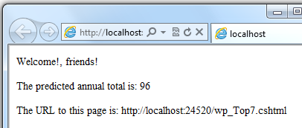

Converting and Testing Data Types
Although ASP.NET can usually determine a data type automatically, sometimes it can't. Therefore, you might need to help ASP.NET out by performing an explicit conversion. Even if you don't have to convert types, sometimes it's helpful to test to see what type of data you might be working with.
The most common case is that you have to convert a string to another type, such as to an integer or date. The following example shows a typical case where you must convert a string to a number.
@{
var total = 0;
if(IsPost) {
// Retrieve the numbers that the user entered.
var num1 = Request["text1"];
var num2 = Request["text2"];
// Convert the entered strings into integers numbers and add.
total = num1.AsInt() + num2.AsInt();
}
}
As a rule, user input comes to you as strings. Even if you've prompted users to enter a number, and even if they've entered a digit, when user input is submitted and you read it in code, the data is in string format. Therefore, you must convert the string to a number. In the example, if you try to perform arithmetic on the values without converting them, the following error results, because ASP.NET cannot add two strings:
Cannot implicitly convert type 'string' to 'int'.
To convert the values to integers, you call the AsInt method. If the conversion is successful, you can then add the numbers.
The following table lists some common conversion and test methods for variables.
Method | Description | Example
AsInt(),  IsInt() | Converts a string that represents a whole number (like "593") to an integer. | var myIntNumber = 0;  var myStringNum = "539";  if(myStringNum.IsInt()==true){  myIntNumber = myStringNum.AsInt();  }
AsBool(),  IsBool() | Converts a string like "true" or "false" to a Boolean type. | var myStringBool = "True";  var myVar = myStringBool.AsBool();
AsFloat(),  IsFloat() | Converts a string that has a decimal value like "1.3" or "7.439" to a floating-point number. | var myStringFloat = "41.432895";  var myFloatNum = myStringFloat.AsFloat();
AsDecimal(),  IsDecimal() | Converts a string that has a decimal value like "1.3" or "7.439" to a decimal number. (In ASP.NET, a decimal number is more precise than a floating-point number.) | var myStringDec = "10317.425";  var myDecNum = myStringDec.AsDecimal();
AsDateTime(),  IsDateTime() | Converts a string that represents a date and time value to the ASP.NET DateTime type. | var myDateString = "12/27/2012";  var newDate = myDateString.AsDateTime();
ToString() | Converts any other data type to a string. | int num1 = 17;  int num2 = 76;  // myString is set to 1776  string myString = num1.ToString() +  num2.ToString();

Operators
An operator is a keyword or character that tells ASP.NET what kind of command to perform in an expression. The C# language (and the Razor syntax that's based on it) supports many operators, but you only need to recognize a few to get started. The following table summarizes the most common operators.
Operator | Description | Examples
+  -  *  / | Math operators used in numerical expressions. | @(5 + 13)  @{ var netWorth = 150000; }  @{ var newTotal = netWorth * 2; }  @(newTotal / 2)
= | Assignment. Assigns the value on the right side of a statement to the object on the left side. | var age = 17;
== | Equality. Returns true if the values are equal. (Notice the distinction between the = operator and the == operator.) | var myNum = 15;  if (myNum == 15) {  // Do something.  }
!= | Inequality. Returns true if the values are not equal. | var theNum = 13;  if (theNum != 15) {  // Do something.  }
<  >  <=  >= | Less-than,  greater-than,  less-than-or-equal, and  greater-than-or-equal. | if (2 < 3) {  // Do something.  }  var currentCount = 12;  if(currentCount >= 12) {  // Do something.  }
+ | Concatenation, which is used to join strings. ASP.NET knows the difference between this operator and the addition operator based on the data type of the expression. | // The displayed result is "abcdef".  @("abc" + "def")
+=  -= | The increment and decrement operators, which add and subtract 1 (respectively) from a variable. | int theCount = 0;  theCount += 1; // Adds 1 to count
. | Dot. Used to distinguish objects and their properties and methods. | var myUrl = Request.Url;  var count = Request["Count"].AsInt();
() | Parentheses. Used to group expressions and to pass parameters to methods. | @(3 + 7)  @Request.MapPath(Request.FilePath);
[] | Brackets. Used for accessing values in arrays or collections. | var income = Request["AnnualIncome"];
! | Not. Reverses a true value to false and vice versa. Typically used as a shorthand way to test for false (that is, for not true). | bool taskCompleted = false;  // Processing.  if(!taskCompleted) {  // Continue processing  }
&&  || | Logical AND and OR, which are used to link conditions together. | bool myTaskCompleted = false;  int totalCount = 0;  // Processing.  if(!myTaskCompleted && totalCount < 12) {  // Continue processing.  }

Working with File and Folder Paths in Code
You'll often work with file and folder paths in your code. Here is an example of physical folder structure for a website as it might appear on your development computer:
C:\WebSites\MyWebSite
default.cshtml
datafile.txt
\images
Logo.jpg
\styles
Styles.css
Here are some essential details about URLs and paths:
- A URL begins with either a domain name (http://www.example.com) or a server name (http://localhost, http://mycomputer).
- A URL corresponds to a physical path on a host computer. For example, http://myserver might correspond to the folder C:\websites\mywebsite on the server.
- A virtual path is shorthand to represent paths in code without having to specify the full path. It includes the portion of a URL that follows the domain or server name. When you use virtual paths, you can move your code to a different domain or server without having to update the paths.
Here's an example to help you understand the differences:
Complete URL | http://mycompanyserver/humanresources/CompanyPolicy.htm
Server name | mycompanyserver
Virtual path | /humanresources/CompanyPolicy.htm
Physical path | C:\mywebsites\humanresources\CompanyPolicy.htm
The virtual root is /, just like the root of your C: drive is \. (Virtual folder paths always use forward slashes.) The virtual path of a folder doesn't have to have the same name as the physical folder; it can be an alias. (On production servers, the virtual path rarely matches an exact physical path.)
When you work with files and folders in code, sometimes you need to reference the physical path and sometimes a virtual path, depending on what objects you're working with. ASP.NET gives you these tools for working with file and folder paths in code: the Server.MapPath method, and the ~ operator and Href method.

Converting virtual to physical paths: the Server.MapPath method
The Server.MapPath method converts a virtual path (like /default.cshtml) to an absolute physical path (like C:\WebSites\MyWebSiteFolder\default.cshtml). You use this method any time you need a complete physical path. A typical example is when you're reading or writing a text file or image file on the web server.
You typically don't know the absolute physical path of your site on a hosting site's server, so this method can convert the path you do know — the virtual path — to the corresponding path on the server for you. You pass the virtual path to a file or folder to the method, and it returns the physical path:
@{
var dataFilePath = "~/dataFile.txt";
}
<!-- Displays a physical path C:\Websites\MyWebSite\datafile.txt -->
<p>@Server.MapPath(dataFilePath)</p>

Referencing the virtual root: the ~ operator and Href method
In a .cshtml or .vbhtml file, you can reference the virtual root path using the ~ operator. This is very handy because you can move pages around in a site, and any links they contain to other pages won't be broken. It's also handy in case you ever move your website to a different location. Here are some examples:
@{
var myImagesFolder = "~/images";
var myStyleSheet = "~/styles/StyleSheet.css";
}
If the website is http://myserver/myapp, here's how ASP.NET will treat these paths when the page runs:
- myImagesFolder: http://myserver/myapp/images
- myStyleSheet : http://myserver/myapp/styles/Stylesheet.css
(You won't actually see these paths as the values of the variable, but ASP.NET will treat the paths as if that's what they were.)
In ASP.NET Web Pages 2, you can use the ~ operator both in server code (as above) and in markup, like this:
<!-- Examples of using the ~ operator in markup in ASP.NET Web Pages 2 -->
<!-- (Using the ~ operator like this in markup is not supported in ASP.NET
Web Pages 1.0) -->
<a href="~/Default">Home</a>
<img src="~/images/MyImages.png" />
In markup, you use the ~ operator to create paths to resources like image files, other web pages, and CSS files. When the page runs, ASP.NET looks through the page (both code and markup) and resolves all the ~ references to the appropriate path.
In ASP.NET Web Pages 1, you can use the ~ operator in server code blocks, like the first example above. But in order to use it in markup, you have to put the ~ operator inside a call to the Href method. (ASP.NET does not parse through the markup looking for the ~ operator.)
For example, you can use the Href method in HTML markup for attributes of <img> elements, <link> elements, and <a> elements. Notice that the Href method is preceded by @ to mark it as server code. Also notice that the Href method is inside the double quotation marks that enclose attribute values.
<!-- Examples of using the Href method in ASP.NET Web Pages 1.0 to include
the ~ operator in markup. -->
<a href="@Href("~/Default")">Home</a>
<!-- This code creates the path "../images/Logo.jpg" in the src attribute. -->
<img src="@Href("~/images")/Logo.jpg" />
<!-- This creates a link to the CSS file using ther server variable. -->
<link rel="stylesheet" type="text/css" href="@Href(myStyleSheet)" />

Conditional Logic and Loops
ASP.NET server code lets you perform tasks based on conditions and write code that repeats statements a specific number of times (that is, code that runs a loop).

Testing Conditions
To test a simple condition you use the if statement, which returns true or false based on a test you specify:
@{
var showToday = true;
if(showToday)
{
@DateTime.Today;
}
}
The if keyword starts a block. The actual test (condition) is in parentheses and returns true or false. The statements that run if the test is true are enclosed in braces. An if statement can include an else block that specifies statements to run if the condition is false:
@{
var showToday = false;
if(showToday)
{
@DateTime.Today;
}
else
{
<text>Sorry!</text>
}
}
You can add multiple conditions using an else if block:
@{
var theBalance = 4.99;
if(theBalance == 0)
{
<p>You have a zero balance.</p>
}
else if (theBalance > 0 && theBalance <= 5)
{
<p>Your balance of $@theBalance is very low.</p>
}
else
{
<p>Your balance is: $@theBalance</p>
}
}
In this example, if the first condition in the if block is not true, the else if condition is checked. If that condition is met, the statements in the else if block are executed. If none of the conditions are met, the statements in the else block are executed. You can add any number of else if blocks, and then close with an else block as the "everything else" condition.
To test a large number of conditions, use a switch block:
@{
var weekday = "Wednesday";
var greeting = "";
switch(weekday)
{
case "Monday":
greeting = "Ok, it's a marvelous Monday";
break;
case "Tuesday":
greeting = "It's a tremendous Tuesday";
break;
case "Wednesday":
greeting = "Wild Wednesday is here!";
break;
default:
greeting = "It's some other day, oh well.";
break;
}
<p>Since it is @weekday, the message for today is: @greeting</p>
}
The value to test is in parentheses (in the example, the weekday variable). Each individual test uses a case statement that ends with a colon (:). If the value of a case statement matches the test value, the code in that case block is executed. You close each case statement with a break statement. (If you forget to include break in each case block, the code from the next case statement will run also.) A switch block often has a default statement as the last case for an "everything else" option that runs if none of the other cases are true.
The result of the last two conditional blocks displayed in a browser:
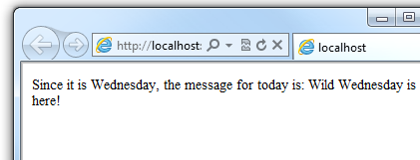

Looping Code
You often need to run the same statements repeatedly. You do this by looping. For example, you often run the same statements for each item in a collection of data. If you know exactly how many times you want to loop, you can use a for loop. This kind of loop is especially useful for counting up or counting down:
@for(var i = 10; i < 21; i++)
{
<p>Line #: @i</p>
}
The loop begins with the for keyword, followed by three statements in parentheses, each terminated with a semicolon.
- Inside the parentheses, the first statement (var i=10;) creates a counter and initializes it to 10. You don't have to name the counter i — you can use any variable. When the for loop runs, the counter is automatically incremented.
- The second statement (i < 21;) sets the condition for how far you want to count. In this case, you want it to go to a maximum of 20 (that is, keep going while the counter is less than 21).
- The third statement (i++ ) uses an increment operator, which simply specifies that the counter should have 1 added to it each time the loop runs.
Inside the braces is the code that will run for each iteration of the loop. The markup creates a new paragraph (<p> element) each time and adds a line to the output, displaying the value of i (the counter). When you run this page, the example creates 11 lines displaying the output, with the text in each line indicating the item number.
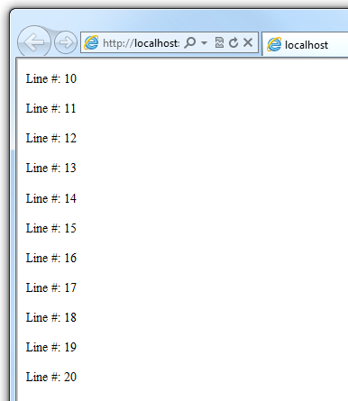

If you're working with a collection or array, you often use a foreach loop. A collection is a group of similar objects, and the foreach loop lets you carry out a task on each item in the collection. This type of loop is convenient for collections, because unlike a for loop, you don't have to increment the counter or set a limit. Instead, the foreach loop code simply proceeds through the collection until it's finished.
For example, the following code returns the items in the Request.ServerVariables collection, which is an object that contains information about your web server. It uses a foreach loop to display the name of each item by creating a new <li> element in an HTML bulleted list.
<ul>
@foreach (var myItem in Request.ServerVariables)
{
<li>@myItem</li>
}
</ul>
The foreach keyword is followed by parentheses where you declare a variable that represents a single item in the collection (in the example, var item), followed by the in keyword, followed by the collection you want to loop through. In the body of the foreach loop, you can access the current item using the variable that you declared earlier.
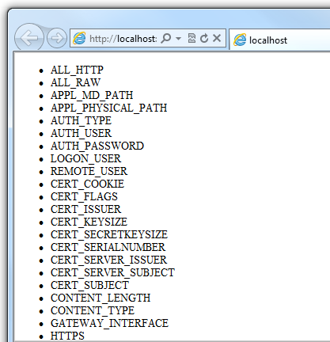
To create a more general-purpose loop, use the while statement:
@{
var countNum = 0;
while (countNum < 50)
{
countNum += 1;
<p>Line #@countNum: </p>
}
}
A while loop begins with the while keyword, followed by parentheses where you specify how long the loop continues (here, for as long as countNum is less than 50), then the block to repeat. Loops typically increment (add to) or decrement (subtract from) a variable or object used for counting. In the example, the += operator adds 1 to countNum each time the loop runs. (To decrement a variable in a loop that counts down, you would use the decrement operator -=).

Objects and Collections
Nearly everything in an ASP.NET website is an object, including the web page itself. This section discusses some important objects you'll work with frequently in your code.

Page Objects
The most basic object in ASP.NET is the page. You can access properties of the page object directly without any qualifying object. The following code gets the page's file path, using the Request object of the page:
@{
var path = Request.FilePath;
}
To make it clear that you're referencing properties and methods on the current page object, you can optionally use the keyword this to represent the page object in your code. Here is the previous code example, with this added to represent the page:
@{
var path = this.Request.FilePath;
}
You can use properties of the Page object to get a lot of information, such as:
- Request. As you've already seen, this is a collection of information about the current request, including what type of browser made the request, the URL of the page, the user identity, etc.
- Response. This is a collection of information about the response (page) that will be sent to the browser when the server code has finished running. For example, you can use this property to write information into the response.
@{
// Access the page's Request object to retrieve the Url.
var pageUrl = this.Request.Url;
}
<a href="@pageUrl">My page</a>

Collection Objects (Arrays and Dictionaries)
A collection is a group of objects of the same type, such as a collection of Customer objects from a database. ASP.NET contains many built-in collections, like the Request.Files collection.
You'll often work with data in collections. Two common collection types are the array and the dictionary. An array is useful when you want to store a collection of similar items but don't want to create a separate variable to hold each item:
@* Array block 1: Declaring a new array using braces. *@
@{
<h3>Team Members</h3>
string[] teamMembers = {"Matt", "Joanne", "Robert", "Nancy"};
foreach (var person in teamMembers)
{
<p>@person</p>
}
}
With arrays, you declare a specific data type, such as string, int, or DateTime. To indicate that the variable can contain an array, you add brackets to the declaration (such as string[] or int[]). You can access items in an array using their position (index) or by using the foreach statement. Array indexes are zero-based — that is, the first item is at position 0, the second item is at position 1, and so on.
@{
string[] teamMembers = {"Matt", "Joanne", "Robert", "Nancy"};
<p>The number of names in the teamMembers array: @teamMembers.Length </p>
<p>Robert is now in position: @Array.IndexOf(teamMembers, "Robert")</p>
<p>The array item at position 2 (zero-based) is @teamMembers[2]</p>
<h3>Current order of team members in the list</h3>
foreach (var name in teamMembers)
{
<p>@name</p>
}
<h3>Reversed order of team members in the list</h3>
Array.Reverse(teamMembers);
foreach (var reversedItem in teamMembers)
{
<p>@reversedItem</p>
}
}
You can determine the number of items in an array by getting its Length property. To get the position of a specific item in the array (to search the array), use the Array.IndexOf method. You can also do things like reverse the contents of an array (the Array.Reverse method) or sort the contents (the Array.Sort method).
The output of the string array code displayed in a browser:
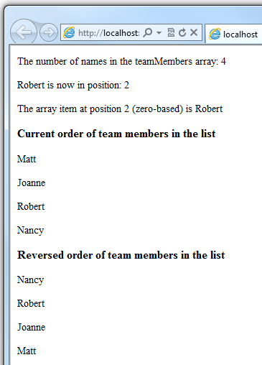
A dictionary is a collection of key/value pairs, where you provide the key (or name) to set or retrieve the corresponding value:
@{
var myScores = new Dictionary<string, int>();
myScores.Add("test1", 71);
myScores.Add("test2", 82);
myScores.Add("test3", 100);
myScores.Add("test4", 59);
}
<p>My score on test 3 is: @myScores["test3"]%</p>
@(myScores["test4"] = 79)
<p>My corrected score on test 4 is: @myScores["test4"]%</p>
To create a dictionary, you use the new keyword to indicate that you're creating a new dictionary object. You can assign a dictionary to a variable using the var keyword. You indicate the data types of the items in the dictionary using angle brackets ( < > ). At the end of the declaration, you must add a pair of parentheses, because this is actually a method that creates a new dictionary.
To add items to the dictionary, you can call the Add method of the dictionary variable (myScores in this case), and then specify a key and a value. Alternatively, you can use square brackets to indicate the key and do a simple assignment, as in the following example:
myScores["test4"] = 79;
To get a value from the dictionary, you specify the key in brackets:
var testScoreThree = myScores["test3"];

Calling Methods with Parameters
As you read earlier in this article, the objects that you program with can have methods. For example, a Database object might have a Database.Connect method. Many methods also have one or more parameters. A parameter is a value that you pass to a method to enable the method to complete its task. For example, look at a declaration for the Request.MapPath method, which takes three parameters:
public string MapPath(string virtualPath, string baseVirtualDir,
bool allowCrossAppMapping);
(The line has been wrapped to make it more readable. Remember that you can put line breaks almost any place except inside strings that are enclosed in quotation marks.)
This method returns the physical path on the server that corresponds to a specified virtual path. The three parameters for the method are virtualPath, baseVirtualDir, and allowCrossAppMapping. (Notice that in the declaration, the parameters are listed with the data types of the data that they'll accept.) When you call this method, you must supply values for all three parameters.
The Razor syntax gives you two options for passing parameters to a method: positional parameters and named parameters. To call a method using positional parameters, you pass the parameters in a strict order that's specified in the method declaration. (You would typically know this order by reading documentation for the method.) You must follow the order, and you can't skip any of the parameters — if necessary, you pass an empty string ("") or null for a positional parameter that you don't have a value for.
The following example assumes you have a folder named scripts on your website. The code calls the Request.MapPath method and passes values for the three parameters in the correct order. It then displays the resulting mapped path.
@{
// Pass parameters to a method using positional parameters.
var myPathPositional = Request.MapPath("/scripts", "/", true);
}
<p>@myPathPositional</p>
When a method has many parameters, you can keep your code more readable by using named parameters. To call a method using named parameters, you specify the parameter name followed by a colon (:), and then the value. The advantage of named parameters is that you can pass them in any order you want. (A disadvantage is that the method call is not as compact.)
The following example calls the same method as above, but uses named parameters to supply the values:
@{
// Pass parameters to a method using named parameters.
var myPathNamed = Request.MapPath(baseVirtualDir: "/",
allowCrossAppMapping: true, virtualPath: "/scripts");
}
<p>@myPathNamed</p>
As you can see, the parameters are passed in a different order. However, if you run the previous example and this example, they'll return the same value.

Handling Errors

Try-Catch Statements
You'll often have statements in your code that might fail for reasons outside your control. For example:
- If your code tries to create or access a file, all sorts of errors might occur. The file you want might not exist, it might be locked, the code might not have permissions, and so on.
- Similarly, if your code tries to update records in a database, there can be permissions issues, the connection to the database might be dropped, the data to save might be invalid, and so on.
In programming terms, these situations are called exceptions. If your code encounters an exception, it generates (throws) an error message that's, at best, annoying to users:
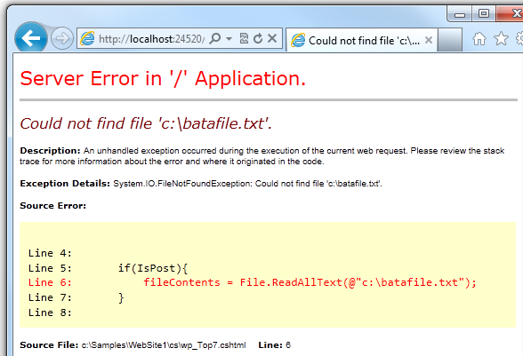
In situations where your code might encounter exceptions, and in order to avoid error messages of this type, you can use try/catch statements. In the try statement, you run the code that you're checking. In one or more catch statements, you can look for specific errors (specific types of exceptions) that might have occurred. You can include as many catch statements as you need to look for errors that you are anticipating.
Note We recommend that you avoid using the Response.Redirect method in try/catch statements, because it can cause an exception in your page.
The following example shows a page that creates a text file on the first request and then displays a button that lets the user open the file. The example deliberately uses a bad file name so that it will cause an exception. The code includes catch statements for two possible exceptions: FileNotFoundException, which occurs if the file name is bad, and DirectoryNotFoundException, which occurs if ASP.NET can't even find the folder. (You can uncomment a statement in the example in order to see how it runs when everything works properly.)
If your code didn't handle the exception, you would see an error page like the previous screen shot. However, the try/catch section helps prevent the user from seeing these types of errors.
@{
var dataFilePath = "~/dataFile.txt";
var fileContents = "";
var physicalPath = Server.MapPath(dataFilePath);
var userMessage = "Hello world, the time is " + DateTime.Now;
var userErrMsg = "";
var errMsg = "";
if(IsPost)
{
// When the user clicks the "Open File" button and posts
// the page, try to open the created file for reading.
try {
// This code fails because of faulty path to the file.
fileContents = File.ReadAllText(@"c:\batafile.txt");
// This code works. To eliminate error on page,
// comment the above line of code and uncomment this one.
//fileContents = File.ReadAllText(physicalPath);
}
catch (FileNotFoundException ex) {
// You can use the exception object for debugging, logging, etc.
errMsg = ex.Message;
// Create a friendly error message for users.
userErrMsg = "A file could not be opened, please contact "
+ "your system administrator.";
}
catch (DirectoryNotFoundException ex) {
// Similar to previous exception.
errMsg = ex.Message;
userErrMsg = "A directory was not found, please contact "
+ "your system administrator.";
}
}
else
{
// The first time the page is requested, create the text file.
File.WriteAllText(physicalPath, userMessage);
}
}
<!DOCTYPE html>
<html lang="en">
<head>
<meta charset="utf-8" />
<title>Try-Catch Statements</title>
</head>
<body>
<form method="POST" action="" >
<input type="Submit" name="Submit" value="Open File"/>
</form>
<p>@fileContents</p>
<p>@userErrMsg</p>
</body>
</html>
Using ASP.NET Razor syntax with HTML5 and JQuery
In this tutorial you will learn how ASP.NET Web Pages with Razor syntax can be used to build a RESTful web service that is capable of delivering weather forecast data to a website using JQuery and the HTML5 Canvas element. We will be using WebMatrix, a lightweight tool for web development to write code and manage the website throughout this tutorial.

Getting Started

The Current Weather Site
The REST service that you will create will be built on top of the Current Weather WebMatrix site that was built in the tutorial Consuming and Storing Data from a REST service with Razor. In that tutorial we learned how the integrated database features of WebMatrix could be used to retrieve and cache weather service data. Some of the code you will be looking at in this tutorial will directly reference the weather forecast features developed for the Current Weather site, so if you would like to familiarize yourself with how the site works, feel free to review that tutorial before continuing.

What You’ll Need
In addition to WebMatrix and the Razor syntax, you will be working with some standard web technologies. If you have a basic understanding of HTML5, CSS, JSON and JavaScript you will be set.

A RESTful Service
The first thing we want to do is review the Razor methods that the Current Weather site uses to retrieve forecast data. The functions we want to use are located in a Razor function block in the App_Code folder of the site. Function blocks are called using the following signature:
FileName.FunctionName([DataType arg], [DataType arg]…);
The filename that the Current Weather site uses is Weather.cshtml and the function is GetForecastByZipcode(string zip). So to call this function using Razor you would write:
@{
var temp = Weather.GetForecastByZipcode("92805");
}
as you can see, we simply pass any valid zip code to the function in order to receive the forecast data for that area. the object that is returned is a simple container that holds the temperature data that is retrieved from a remote weather service.
public class temperature
{
public string zip { get; set; }
public string latitude { get; set; }
public string longitude { get; set; }
public int maxtemp { get; set; }
public int mintemp { get; set; }
public string forecast { get; set; }
}
each property of the temperature object can be easily accessed through the ‘temp’ variable. for example, the following razor code will write the forecast description into an html paragraph:
<p>@temp.forecast</p>
so now that now you understand how weather forecast data is accessed, let’s take a look at how the data stored in the temperature object can be converted to a format that is consumable by other applications.

What is REST
a restful web service is simply a service that is implemented using http as a protocol. that means that requests are made from client to server using a valid uri as a locator. a typical restful api will respond to requests with a standards compliant data format like json or xml. for this tutorial you will be creating a very simple service layer on top of the getforecastbyzipcode method that we discussed in the last section.

Using Razor to Deliver RESTful Content
in order to create a restful web service layer on top of the current weather site, we will need to add some code that accepts a client supplied zip code and returns data in a standardized format. so let’s start by creating an empty razor page to hold the required code. for this tutorial we are using a page called jsonservice.cshtml, but you are free to name it anything you like. this page will only contain a small razor code block, so any default html can safely be removed.
now that we have a place to hold the service code, let’s discuss how we can add support for accepting zip codes. since a restful web service is implemented over http, the simplest means of passing http compliant data into a url is with query string parameters. so let’s add a code block the page and extract a query parameter from the request object called ‘zip’.
@{
var zip = request.querystring["zip"];
}
now whenever a request is made to the following url:
http://localhost/CurrentWeather/JsonService.cshtml?zip=92805
the razor variable, zip, will contain the requested zip code. you will also probably want to make sure that if the zip parameter is missing that the page handles it appropriately. so let’s add a little more code to make sure that the request is properly formatted.
@{
var zip = request.querystring["zip"];

if(zip == null){
response.write("Missing Zip Parameter");
return;
}

if(zip != string.empty){
//zip code exists
}else{
response.write("Invalid Zip Code");
}
}
if either the zip parameter is missing a value or not even included in the url, the client that issued the request will receive a simple message indicating what went wrong.
alright, so now that we have a zip code supplied by a client request, we can retrieve the weather forecast data using the same function call to getforecastbyzipcode we looked at earlier. however we still need a convert the data held in the temperature object to a format that any client can consume. to do this we will be using the javascript object notation (json) protocol. json is a text-based open standard that has become the leading interchange format for sharing data in a web environment. the json standard uses a concise key/value pair format that is perfect for parsing data into a readable format. although the json specification is well documented, the code required to convert a razor object into json would be pretty lengthy to write yourself. thankfully, the webmatrix environment comes preinstalled with a json helper that simplifies the process of encoding and decoding objects into a few simple functions.
let’s take look at how the webmatrix json helper can be used to encode and decode the temperature object returned by the getforecastbyzipcode function by adding some test output to the service page.
if(zip != string.empty){
//zip code exists
var temp = weather.getforecastbyzipcode("92805");
response.write("<p>" + temp.forecast + "</p>");

var json = json.encode(temp);
response.write("<p>" + json + "</p>");

var temp2 = json.decode(json);
response.write("<p>" + temp2.forecast + "</p>");

json.write(temp, response.output);
}else{
response.write("Invalid Zip Code");
}
if you were to run this code in a browser from within the current weather site you would see the following page output:
partly sunny
{"Zip":"92805","Latitude":"33.8263","Longitude":"-117.911","MaxTemp":66,"MinTemp":50,"Forecast":"Partly Sunny"}
partly sunny
{"Zip":"92805","Latitude":"33.8263","Longitude":"-117.911","MaxTemp":66,"MinTemp":50,"Forecast":"Partly Sunny"}
the json helper contains two methods, encode and decode, which are used to convert the temperature object in and out of a json formatted string. notice that the encoded output has converted the properties of the temperature object to keys and associated the property data to each key as a string value. when the json string is decoded, the properties of the object can once again be accessed as they were prior to encoding. since we only need to encode and write directly to the response stream, the process can be simplified through the use of the json.write method as demonstrated in the last line of code.

A Quick Test
your final output of the rest service should look something like this:
@{
var zip = request.querystring["zip"];

if(zip == null){
response.write("Missing Zip Parameter");
return;
}

if(zip != string.empty){
var temp = weather.getforecastbyzipcode(zip);
json.write(temp, response.output);
}else{
response.write("Invalid Zip Code");
}
}
now whenever a valid zip code is sent to the service, the requesting client will receive a json formatted string that can be decoded by a native json parser.

A Web Client with HTML5
after years of waiting, the html5 standard is finally starting to find its way into all the modern browsers. this opens the path to rich client experiences without the need for additional browser plugins. the canvas element provides access to a powerful api that is capable of rendering the type of vector based graphics and animations that you would expect to see in flash or silverlight. in this section, we will look at how the canvas api and ajax can be combined to dynamically communicate with the current weather site using the rest service we just created.

Using JQuery and AJAX
to allow the canvas element to receive updates without having to do a full page load, we will use ajax to send zip code requests to the rest service in the background. we will be using the jquery javascript library to simplify our interaction with ajax. if you are not familiar with jquery, feel free to take a look at the tutorials and documentation available at jquery.com. the jquery library provides an amazing array of cross-browser compatible features that remove a lot of the complexity involved in client side programming. let’s take a quick look at how we can use the ajax features in jquery to call the rest service page without requiring a page reload. for demonstration purposes, let’s add the following code to a new razor page called jqueryweather.cshtml. this page should be added under the same path as the jsonservice.cshtml file we created in the previous section.
<script src="http://ajax.microsoft.com/ajax/jQuery/jquery-1.5.js" type="text/javascript"></script>
<script type="text/javascript">
var index = 0;
var zipcodes = new array();
zipcodes[0] = "02125";
zipcodes[1] = "60611";
zipcodes[2] = "90001";
zipcodes[3] = "33122";
zipcodes[4] = "70112";
zipcodes[5] = "10012";
zipcodes[6] = "98101";

$(document).ready(function(){
updateweather();
});

function updateweather(){
$.getjson('/JsonService',{ zip:zipcodes[index] }, function(data) {
$("#json").html("<ol>" +
"<li>Location: " + zipcodes[index] + "</li>" +
"<li>Forecast: " + data.forecast + "</li>" +
"<li>High: " + data.maxtemp + "</li>" +
"<li>Low: " + data.mintemp + "</li>" +
"</ol>");

if(index > 5) index = 0;
else index++;

settimeout("UpdateWeather()", 3000);
});
}
</script>
<div id="json"></div>
in this example, we have created an array of zip codes that are used to request weather data from the rest service page. as soon as the dom has loaded the updateweather function is called. the updateweather function performs the ajax request and sets a timer that will call the function again after three seconds have passed. the getjson function is a shortcut to jquery’s ajax api that removes some of the additional parameters required to work json data. in short, getjson is given the rest service url, a zip code selected from the array incrementally, and a function that will execute as soon as data is retrieved from the service. the jquery ajax api will assemble the url and zip code value into the valid query string required by the service. the data is returned as a json object derived from the properties and values of the temperature object that is used by the razor server code. notice that when the data is written to the div html element, that the individual temperature values are accessed using the exact same property names that we created in razor. if you were to run this code, it would iterate through the zip code array every three seconds and dynamically update the web page after each response.

Building an Interface with the Canvas Element
alright, now let’s look at how we can take advantage of the canvas element to create a nice, polished user interface to consume this data.
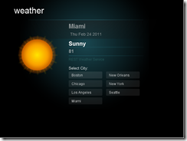
the picture above is a screen capture of the vector graphics rendered by two canvas elements on a single web page. the buttons and other static content are rendered on a canvas element that acts as a bottom layer. the weather icon and forecast information is rendered on a separate canvas element that is positioned on top of the bottom layer. when a city is selected, the top layer is reset and updated weather data is written to the canvas. the following html will be added to the default.cshtml page that was created with the site.
<html lang="en">
<head>
<script src="http://ajax.microsoft.com/ajax/jQuery/jquery-1.5.js" type="text/javascript"></script>
<script src="/Content/Scripts/JScript.js" type="text/javascript"></script>
<style type="text/css">
body{
margin: 0;
}
canvas{
position:absolute;
left:0px;
top:0px;
}
#canvasStage{
background: #000;
z-index:1;
}
#canvasText{
z-index:2;
}
</style>
<meta charset="utf-8" />
<title>Current Weather</title>
</head>
<body>
<div id="canvasContainer">
<canvas width="640" height="480" id="canvasStage"></canvas>
<canvas width="640" height="480" id="canvasText"></canvas>
</div>
<div id="weather"></div>
</body>
</html>
as you can see in the code above, both canvas elements are set at the same height and width. then using css, they are positioned directly on top of each other using the z-index property. in order to render content to a canvas element, you will need to interact with it through the dom using javascript. notice that there is a separate script tag that references a javascript file called jscript.js. let’s take a look at that next.
var canvas;
var canvasText;

$(document).ready(function(){
canvas = document.getElementById('canvasStage');
canvasText = document.getElementById('canvasText');
if(canvas.getContext){
drawBackground();
createButtons();
checkWeather(button1);
}else{
$("#canvasContainer").html("Your browser does not appear to support the HTML5 Canvas element");
}

$('canvas').click(function(e){
buttonClick((e.clientX-canvas.offsetLeft), (e.clientY-canvas.offsetTop));
});
});
once again, we wait until the dom has completely loaded before performing any other operations. then we create instances of the two canvas elements that are used to render the graphics and weather data. there is a simple browser check in place so that browsers that are not able to display canvas content will display a warning message. if the browser is supported, the content is then rendered. the function drawbackground is responsible for setting up the background on the canvasstage element. once the background is rendered, the createbuttons function will use hard coded city information to create an array of button objects. the button object is just a custom javascript object that is used to hold the name and zip code of the individual cities that are displayed. finally, a click event is registered to all canvas elements on the page. by comparing the mouse coordinates at the time of the event with the location and size of the selected button, the buttonclick function can determine which, if any, of the listed cities were clicked.
function buttonClick(x,y){
for (var i = 0; i < buttons.length; i++){
var button = buttons[i];
if(x > button.X && x < (button.X + button.Width)){
if(y > button.Y && y < (button.Y + button.Height)){
checkWeather(button);
break;
}
}
}
}
when a valid click is detected, the button object is passed to the checkweather function and used to display the name of the city and request weather data from the jsonservice.
function checkWeather(button){
wait(button.Text);

$.getJSON('/JsonService',{ zip:button.Location }, function(data) {
updateLocation(data, button);
})
}
the caching logic used by the current weather website is designed to only make requests from the remote weather service when the local data for a selected location has expired. when this happens there can be a delay while the site is waiting for fresh data. the wait function renders a loading screen using the name of the selected location. this function is called before every request so that if the request takes more than a few milliseconds the user is presented with some immediate feedback. the following picture shows the loading screen that is displayed when the weather for the boston area has to be refreshed.
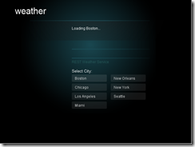
the wait function demonstrates how javascript is used to interact with api exposed by the canvas element. to interface with the api a reference to the primary context of the canvas element must be requested. the wait function uses the 2d context of the top layer canvastext element to write the loading message that you see in the picture above. in the case that the canvastext element already has content rendered to it, the entire content area is cleared before writing the loading message.
function wait(city){
var ctx = canvasText.getContext('2d');
ctx.clearRect(0,0,640,480);
ctx.fillStyle = '#fff';
ctx.font = '12px sans-serif';
ctx.fillText ('Loading ' + city + '...', 240, 100);
}
when the jsonservice request has completed the callback function passes the response data and requesting button object to the updatelocation function.
function updateLocation(weather, button){
var ctx = canvasText.getContext('2d');
ctx.clearRect(0,0,640,480);
ctx.save();

ctx.fillStyle = '#fff';
ctx.font = 'bold 20px sans-serif';
ctx.fillText (weather.Forecast, 240, 160);

ctx.fillStyle = 'rgba(205,205,205,.7)';
ctx.font = 'bold 16px sans-serif';
ctx.fillText (weather.MaxTemp, 240, 185);

ctx.font = 'bold 22px sans-serif';
ctx.fillText (button.Text, 240, 100);

ctx.font = '14px sans-serif';
ctx.fillText (new Date().toDateString(), 245, 125);

var sun = /(sun|sunny|sunshine|clear)/i;
var cloud = /(cloud|fog|haze|overcast|blustery)/i;
var snow = /(snow|flurries|ice)/i;
var rain = /(rain|shower|drizzle)/i;
var storm = /(storm|thunder|lightning)/i;

if(weather.Forecast.search(sun) >=0){
drawSun(ctx,60,120);
}else if(weather.Forecast.search(cloud)>=0){
drawCloud(ctx,40,150);
}else if(weather.Forecast.search(snow)>=0){
drawCloud(ctx,40,150);
}else if(weather.Forecast.search(rain)>=0){
drawRain(ctx,40,200);
}else if(weather.Forecast.search(storm)>=0){
drawThunder(ctx,20,20);
}
ctx.restore();
}
the updatelocation function once again clears the canvastext area, removing the loading message from the context. the weather data that was returned from the jsonservice is then rendered to the context. the user interface that we are using only includes a few weather icons for this tutorial, so to decide which icon to render a very basic conditional lookup is used to extract common weather terms from the forecast and assign an icon. the code required to generate the visual elements can get pretty lengthy and repetitive, so in this tutorial we will only provide a brief overview of the approach that was used. to see the full source for the full weather widget, take a look at the javascript file included in the demonstration site.
the weather icon rendering functions that are called from the updatelocation function, accept a context object along with the desired coordinates for icon positioning as parameters. in the following example you can see how the weather icon for thunder is rendered.
function drawThunder(ctx, x,y){
ctx.translate(x,y);
ctx.beginPath();
ctx.moveTo(185.15397,137.33667);
ctx.lineTo(133.81479,136.96566);
ctx.lineTo(124.17756,159.20675);
ctx.lineTo(147.34501,159.02141);
ctx.lineTo(127.51367,187.37837);
ctx.lineTo(146.2327,186.08124);
ctx.lineTo(130.66444,217.95941);
ctx.lineTo(185.89568,168.28854);
ctx.lineTo(165.87861,168.1032);
ctx.lineWidth=2;
ctx.fillStyle="white";
ctx.fill();
}
the lineto function is used to draw a continuous line in the shape of a lightning bolt. when the shape is complete it is filled with the color white. you can see what it looks like when rendered to the page in the following picture:
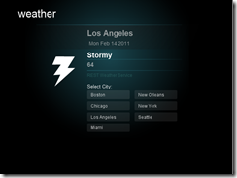

Summary
in this tutorial you saw how webmatrix can be used to create a restful content delivery service that can be consumed by a variety of user interfaces. you learned how webmatrix can be used to build sophisticated client pages using the latest standards like html5 and jquery.
webmatrix was created from the ground up to be a simple, all-inclusive web development tool that is easy to use but still powerful enough to deliver the advanced features used by websites today.

